LAB 1 – Azure Data Factory

1. 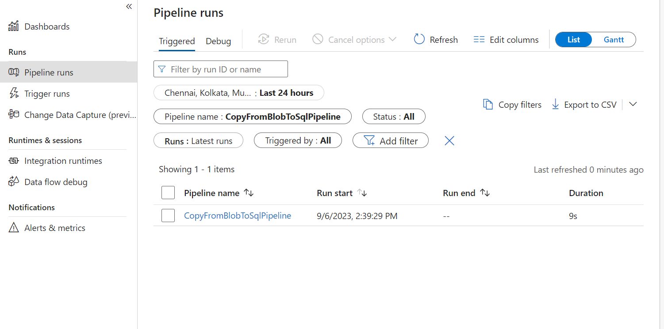

LAB 2 – Azure Data Factory